Review of about 50 trees form the Swedish tree bank.

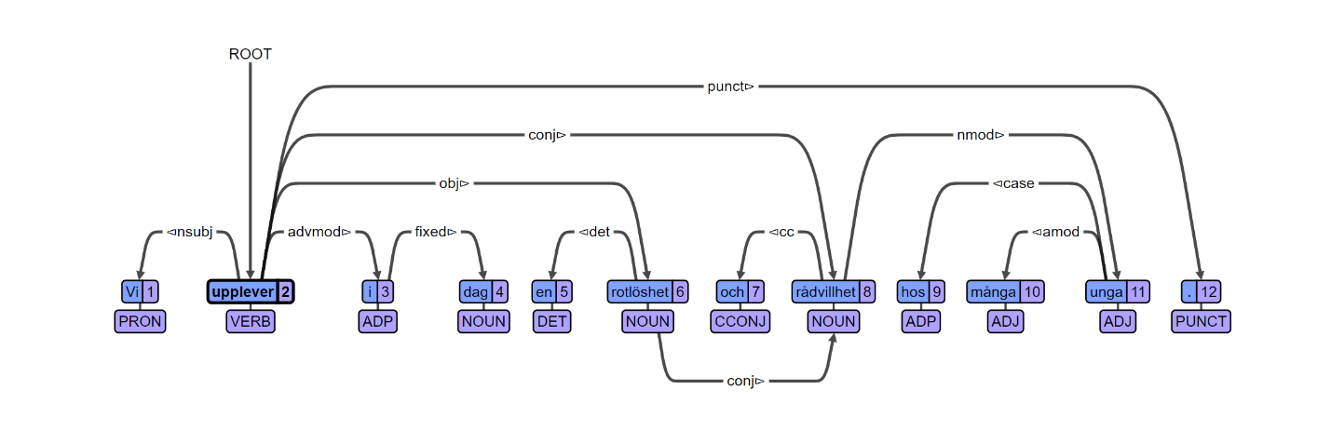Here we have the word <<rådvilhet>> which is being referenced to by two heads (two separate conj. arcs).

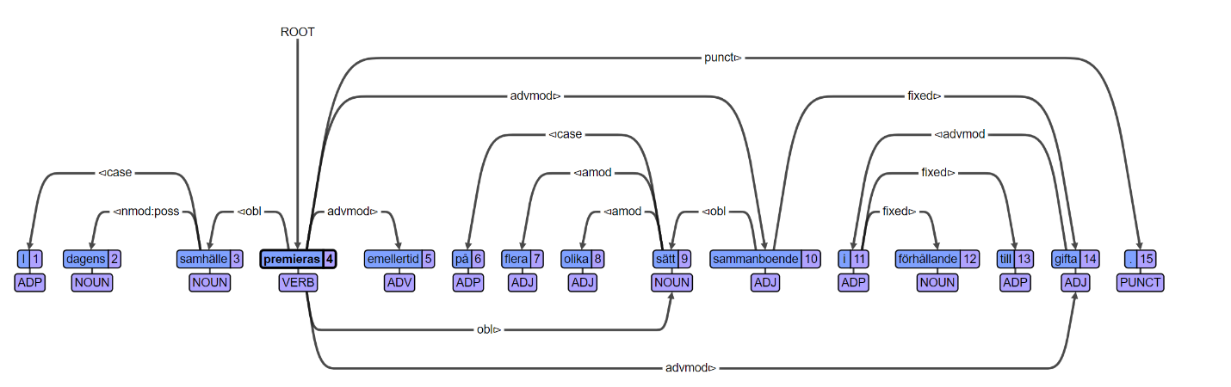

Here we have the word <<sammanboende>> (living-together) labeled as an ADJ, however, I believe it would be more correctly labeled as a noun. As well the “fixed” relationship to <<gifta>> (marriage) is strange.

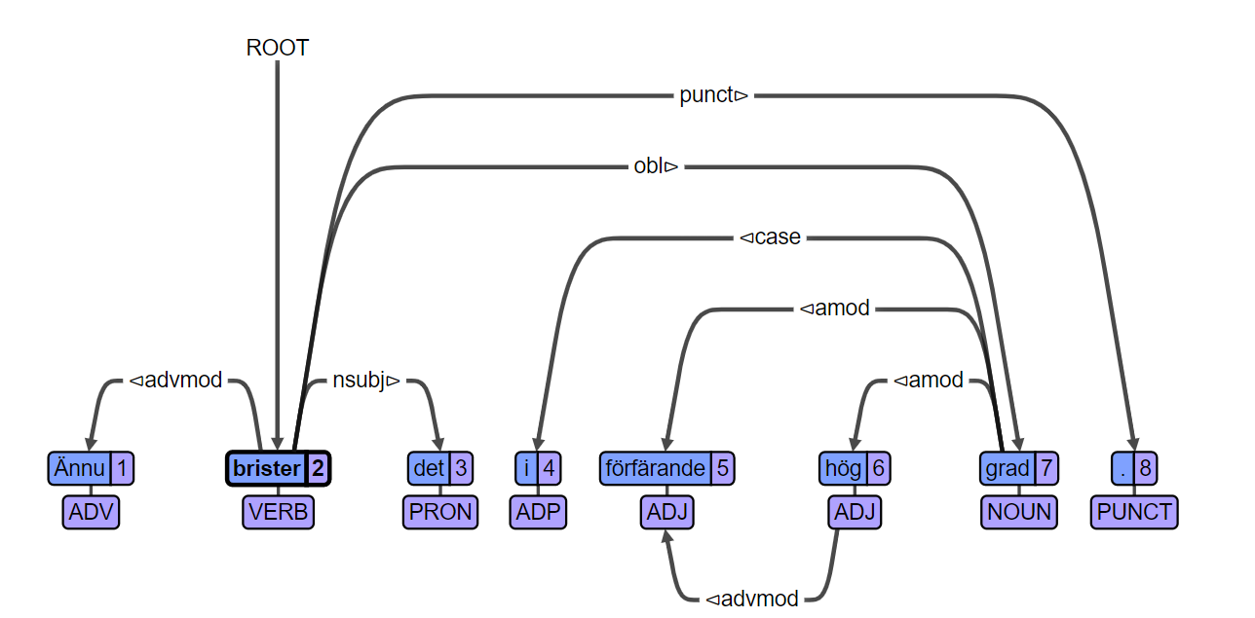

Here we have <<hög>> having a relationship with either <<grad>> or <<förfärande>> which makes not a lot of sense. Either “appallingly high” or “high degree”.

åäö

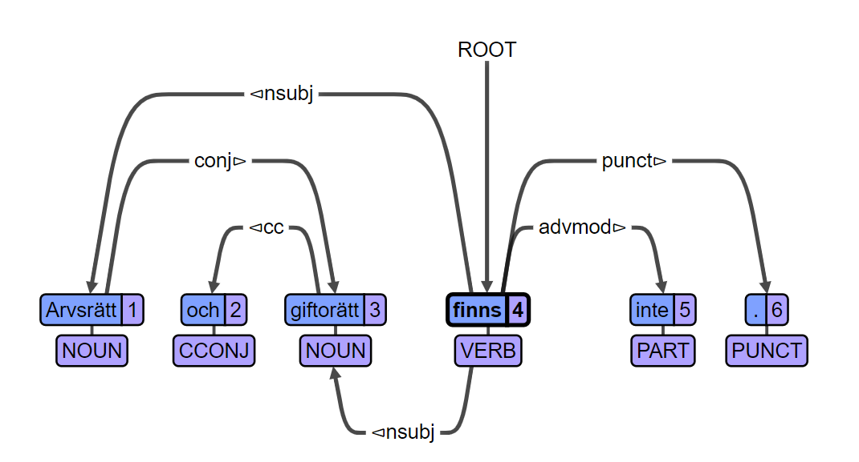

Here we have a mistake with the enhanced graph. We are shown that <<giftorätt>> has two heads, one being the subject of the verb and the other, the conjunction with <<arvsrätt>>.

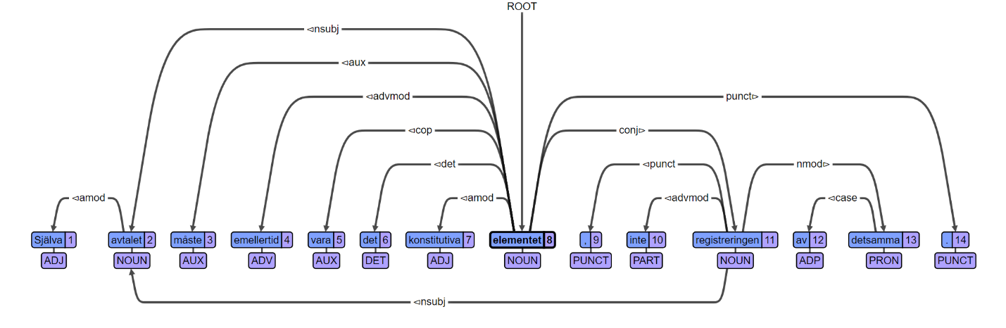

Here we have another mistake with the enhanced coding. We have that <<registreringen>> refers to the noun <<avtalet>> giving it two heads. – åäö –

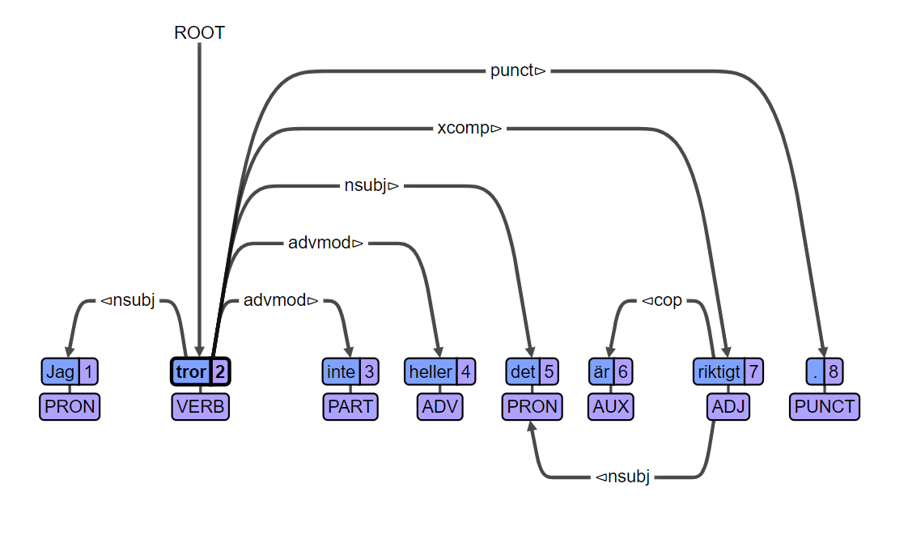

Here I think there is a mislabelling of the arc to <<det>> as I do not think it should be marked as nsubj. Especially since this would give <<tror>> two nsubj.

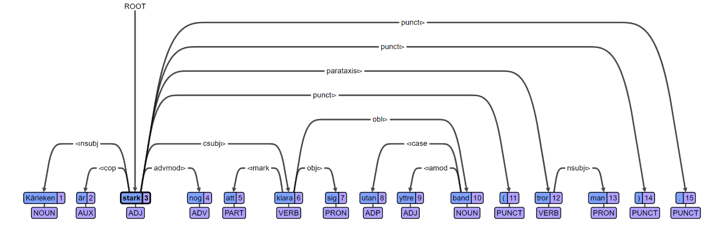

I just thought this tree was interesting as it uses parataxis in it. It was also discussed that there is a problem with it being labelled with two subjects. This could be remedied by replacing the csubj. with some sort of adverbial modifier.